Sunday 1st March 2026


Choral Evensong
Next Sunday 8th March at 5.30pm
All welcome for this traditional choral evening service, with Lenten hymns and anthems.

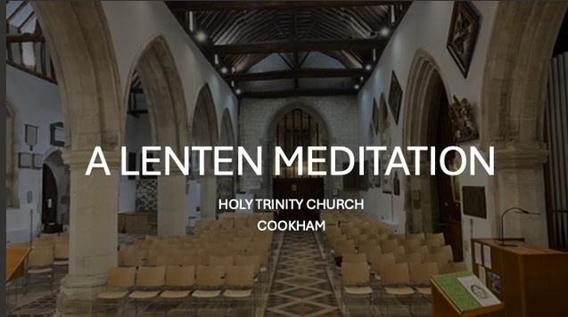
A Lenten Meditation
Available online (YouTube: Cookham Choirs) and https://youtu.be/7kJF2Rng44E


Lent Course
Thursdays at 2.00pm in HTC
Discovering Jesus through the Eucharist
Explore the profound meal at the heart of Christian life - whether you’re new to Christianity or have been coming to church for years. Come and See is a free experience to explore spirituality and find out more about the Christian faith. Sign up below to get daily emails through Lent, with reflections, readings and encouragements. Each week we will be unpacking another aspect of the Eucharist. Thursdays throughout Lent at 2.00pm in HTC 5/12/19/26 March
No need to book – just come along!

New Safeguarding email address
Safeguarding is an integral part of the mission and ministry of the Church of England. If you have concerns about safeguarding issues you can contact our Safeguarding Officer Andra Rigby on the new email address: htcsafeguarding@outlook.com
Or the Diocese Safeguarding team:
01865 208 295 or email safeguardingreferrals@oxford.anglican.org


Thursday Mornings at 9.00am
Please join us for our regular prayer meeting on Thursday mornings in HTC. We pray for the prayer requests and any other needs made known to us. Please let Andy Oxley know of any requests or write your request on a card and leave it on the board at the back of the church. All welcome

Thursday Mornings 9.30-11.30am
All parents and carers are welcome to drop in for crafts, toys stories and songs with refreshments in the Parish Centre. Free!


Please pray for those who are ill and for those who care for them…
Liz Purcell, Eileen Seal, and Archie Kind
Please pray for those who have died…
Stephen Wray RIP, Morag Murray RIP and
Mette Barry RIP

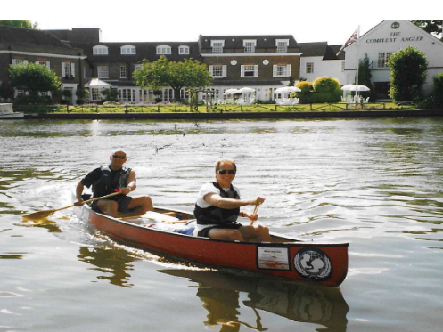
TRINITY TALK Monday 16 March
Life is like paddling a canoe down a river
Author and former teacher Phil Waterton and his friend Kev celebrated their 50th birthdays by travelling the Thames from its source at Cricklade to Teddington Lock. Their trip, in a two-man Canadian canoe, took 12 days and included visiting every pub with a riverside fronting to partake of a drink (or two). Phil’s talk captures daily incidents and describes the natural history and the historic towns and villages along the banks of the Thames.
Trinity Talks are held monthly at Bel and The Dragon in Cookham High Street. They celebrate the talents of people living in Cookham and its environs and raise funds for Holy Trinity Church.
Everyone is welcome, but capacity is limited, so it is advisable to check in advance. When reserving your place at £20 each by phone on 07870 788092 or email stephaniediggon@hotmail.com, please let me know of any food allergies. Pay cash on arrival from 6.30pm (for Prosecco and canapés). Talks start at 7pm and finish around 8pm.

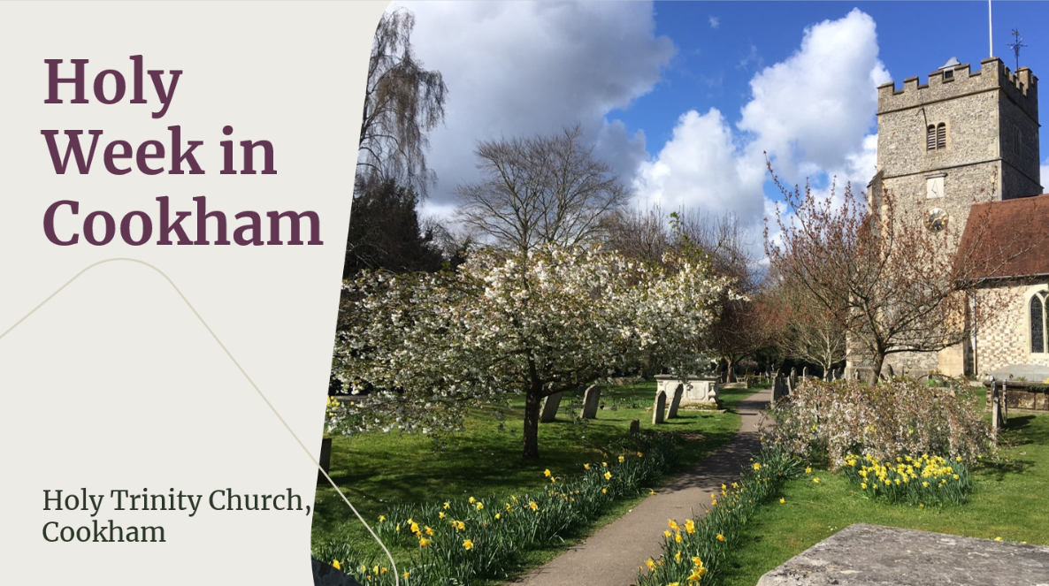
Palm Sunday 29th March
10.45 Meet at the War Memorial and walk to HTC with our Palm Crosses
Monday 30th March
Liturgy of Shadows:
7.00pm St John the Baptist
Tuesday 31st March
Service of Prayer, Reflection and Song
7.00pm Cookham Rise Methodist Church
Wednesday 1st April
Taizé service
7.00pm Holy Trinity Church
Maundy Thursday 2nd April
Eucharist and Watch:
7.00pm St John the Baptist
Good Friday 3rd April
10.30am Hot Cross Buns at St John the Baptist
11.00am Walk of Witness followed by refreshments at HTC
2.00pm Good Friday Liturgy HTC
Easter Saturday Vigil 4th April
Blessing of Fire and Eucharist
7.30pm Holy Trinity Church
Easter Sunday 5th April
9.15am St John the Baptist,
10.00am Holy Trinity Church
Please note time of HTC service
5.30pm Easter Carol Service HTC

Ministry at HTC

Vicar, Fr Stephen Mills
vicarofthecookhams@outlook.com

Reverend Sophie Troczynska
rev.troczynska@outlook.com

Churchwardens
Bernadette Clark 01628 530047
Andy Oxley 07757 162892

Director of Music
Sara Wood 01628 522593
Assistant Director of Music
Victoria Wood 01628 522593

Bell Ringers
Mandy Salter 01628 530241

Verger
Malcolm Sturges 07710557015
Jill Cruse (Assistant Verger) 07941 994640

Safeguarding Officer
Andra Rigby
htcsafeguarding@outlook.com

Pew News Contributions
Operations Manager & Parish Administrator
Andra Rigby The Parish Office, Church Gate, Cookham, SL6 9SP 01628 529661 office@cofe-thecookhams.org.uk

